**Commodore VIC-20 Diagnostic Keyboard PCB Rev. 0**

**Module Description**

The Keyboard PBC provides the feedbacks for the keyboard connector, which are required for the Commodore VIC-20 Diagnostic software. The LED works as an alternative Power LED.

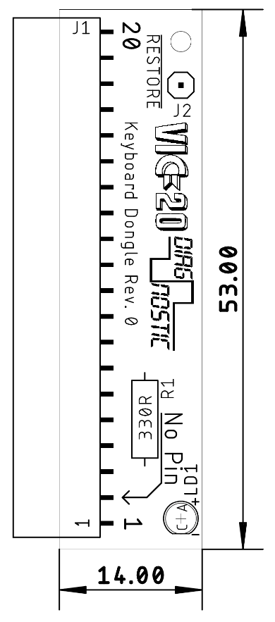

Figure 1: Dimensions of the Keyboard PCB

# Connectors

## Keyboard Connector (J1)

| Pin | Signal |
| --- | --- |
| 1 | GND |
| 2 | No Pin |
| 3 |  |
| 4 | +5V |
| 5 | COL7 |
| 6 | COL6 |
| 7 | COL5 |
| 8 | COL4 |
| 9 | COL3 |
| 10 | COL2 |
| 11 | COL1 |
| 12 | COL0 |
| 13 | ROW7 |
| 14 | ROW6 |
| 15 | ROW5 |
| 16 | ROW4 |
| 17 | ROW3 |
| 18 | ROW2 |
| 19 | ROW1 |
| 20 | ROW0 |

## Cable (J2)

This is a solder pad for the RESTORE Cable (Doc.-No. 159-3-04-**) from the cable set. The cable is soldered to the pad and a knot serves as a strain relief.

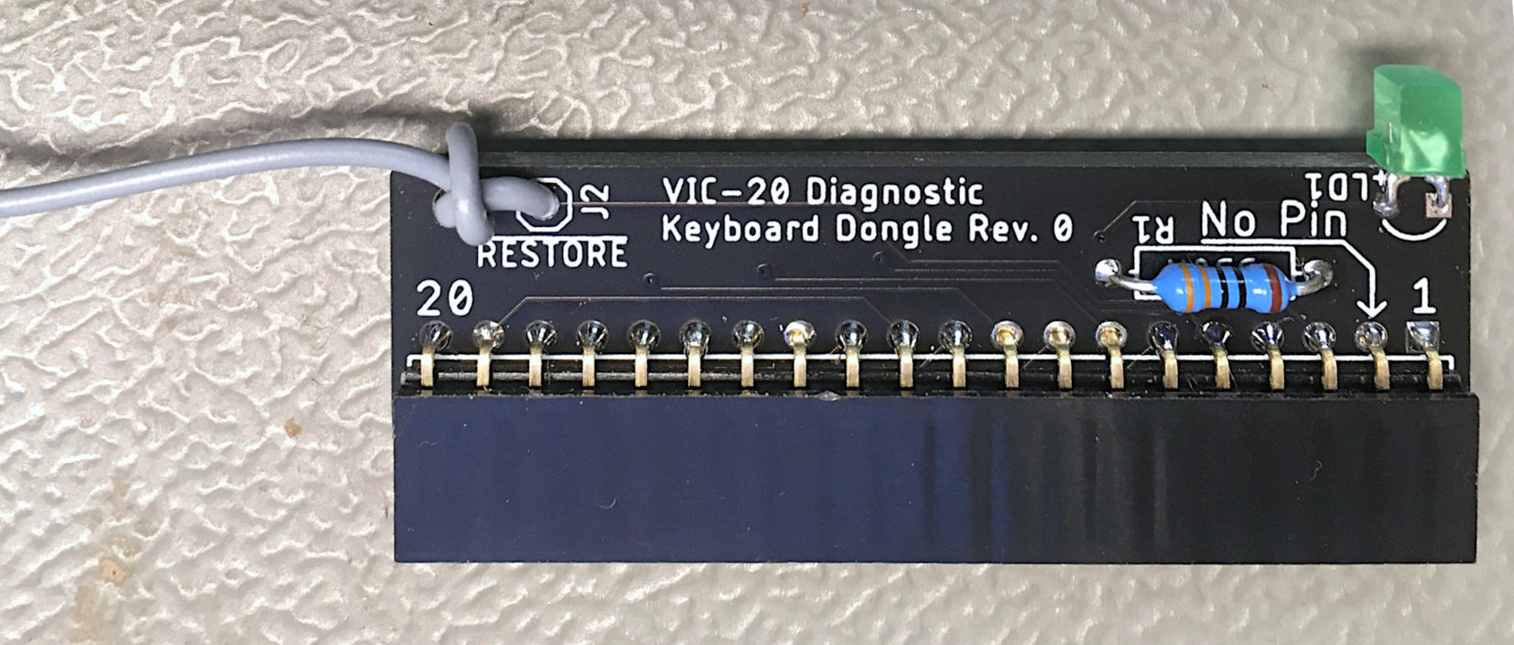

Figure 2: Keyboard PCB with the RESTORE cable soldered to J2 and tied to the PCB

This cable is connected to a single pin of the User Port PCB.

# Interconnects

|  |  |  |
| --- | --- | --- |
| Signal |  | Signal |
|  | → | User Port Pin 9 (ATN) |
| COL7 | ↔ | ROW7 |
| COL6 | ↔ | ROW6 |
| COL5 | ↔ | ROW5 |
| COL4 | ↔ | ROW4 |
| COL3 | ↔ | ROW3 |
| COL2 | ↔ | ROW2 |
| COL1 | ↔ | ROW1 |
| COL0 | ↔ | ROW0 |